Error Boundary:
Error boundary are React component that catch javascript errors anywhere in their child component tree ,logs those errors and display a fallback UI instead of the component tree that crashed .
Error boundary catch errors during rendering,in lifecycle methods and in constructors of the whole tree below them.
Note:
Error boundaries do not catch errors for:
- Event handlers
- Asynchronous code (e.g. setTimeout or requestAnimationFrame callbacks)
- Server side rendering
- Errors thrown in the error boundary itself (rather than its children)

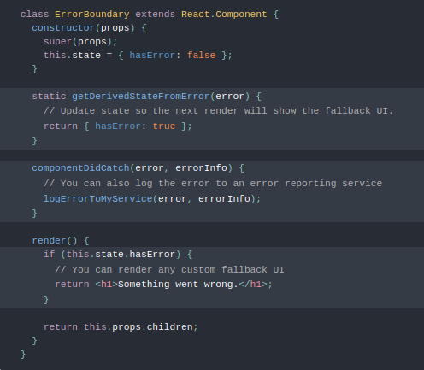
# A class component becomes an error boundary if it defines either (or both) of the lifecycle methods static getDerivedStateFromError() or componentDidCatch(). Use static getDerivedStateFromError() to render a fallback UI after an error has been thrown. Use componentDidCatch() to log error information.

Custom Hooks:
Custom hooks are functions in React that allow you to reuse stateful logic across different components.
They were introduced in React 16.8 as a way to share logic between components without relying on class components or duplicating code.
Custom hooks are regular JavaScript functions, but their names conventionally start with the word "use" to indicate that they might use React state features.

To create a custom hook, follow these steps:
- Define the Custom Hook:
    - Start by creating a JavaScript function. The function can use any of the React hooks.
    - Use parameters if your hook needs dynamic values.
    - The hook should return the state, functions, or any values you want to share.

- Use the Custom Hook in Components:

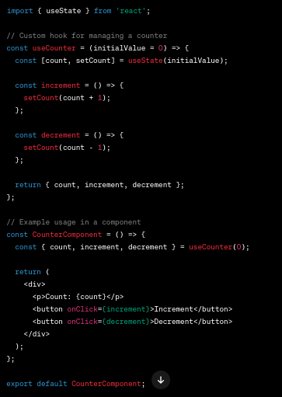

Debounce function:
In JavaScript, debounce is a js concept used to optimize event handling by delaying the execution of a function until after a specified period of inactivity. It helps prevent excessive function calls triggered by rapid events, such as keystrokes or scroll movements.

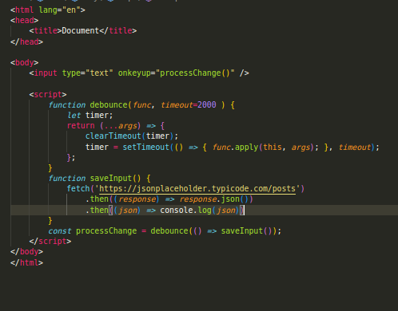

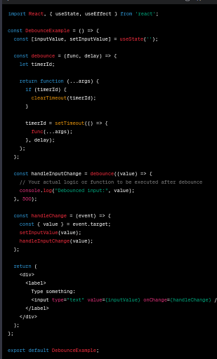

Routing in React js
Routing in React refers to the process of navigating between different views or components in a React application based on the current URL or user interactions.
Setup of Routing
version:
react-router: 6.9.0
react-router-dom:6.9.0

router.js

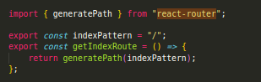
App.js

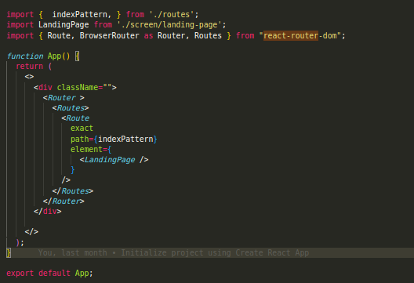
.

Header.js

